**Module -1: Understanding of Hardware and Its Components**

Section 1: Multiple Choice

**1. Which of the following is NOT a component of the CPU?**

**1. ALU**

**2. RAM**

**3. CU**

**4. 1 and 3 both**

**2. What is the function of RAM in a computer?**

🡪 store data

**3. Which of the following is a primary storage device?**

**1. HDD**

**2. SSD**

**3. SD card**

**4. 1 and 2 both**

**4. What is the purpose of a CPU?**

🡪 CPU (central processing unit) is used for processing the data

Section 2: True or False

**5. True or False: The motherboard is the main circuit board of a computer where other components are attached.**

🡪 True

**6. True or False: A UPS (Uninterruptible Power Supply) is a hardware device that provides emergency power to a load when the input power source fails.**

🡪True

**7. True or False: An expansion card is a circuit board that enhances the functionality of a component.**

🡪True

Section 3: Short Answer

**8. Explain the difference between HDD and SSD.**

🡪 **HDD:** Uses spinning magnetic disks (platters) and read/write heads to access data.

* It is slower compared to SSD

**SSD:** Uses flash memory chips to store data electronically, with no moving parts.

* It is faster compared to HDD

**9. Describe the function of BIOS in a computer system.**

🡪 **BIOS (basic input/outout system)** initializes and tests hardware components during startup loads the operating system from storage into memory and provides a setup interface for configuring system settings.

**10. List and briefly explain three input devices commonly used with computers.**

🡪 1. **Keyboard:**

* **Function:** A keyboard allows users to input text and enter data.

2. **mouse:**

• **Function:** for selecting items and navigating.

3. **Scanner:**

* **Function:** A scanner converts physical documents or images into digital format.

Section 4: Practical Application

**11. Identify and label the following components on a diagram of a motherboard: ● CPU ● RAM slots ● SATA connectors ● PCI-E slot**

🡪 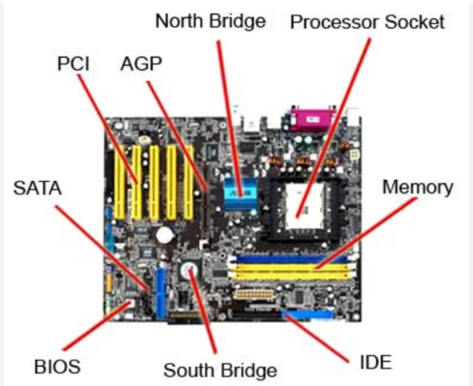



**12. Demonstrate how to install a RAM module into a computer.**

🡪 To install the new RAM, align the notch on the RAM stick with the ridge in the slot, and firmly press the RAM into the slot until the side clips snap into place, securing the RAM.

Section 5: Essay

**13. Discuss the importance of proper cooling mechanisms in a computer system. Include examples of cooling methods and their effectiveness.**

🡪 Proper cooling mechanisms in a computer system are crucial for maintaining performance, reliability, and longevity of the hardware. Overheating can lead to several issues

**Examples of Cooling Methods**

1. **Air Cooling**:
   * **Fans**: The most common cooling method, using fans to circulate air over heatsinks. Fans are generally effective for moderate cooling needs and are often found in standard desktop computers and laptops.
   * **Heatsinks**: Made of metal (often aluminum or copper), heatsinks dissipate heat away from the component to the surrounding air. They work by increasing the surface area in contact with the air, which helps transfer heat away.
2. **Liquid Cooling**:
   * **Closed-Loop Systems (All-in-One)**: These systems include a pre-filled, sealed liquid loop with a pump, radiator, and fans. They offer better cooling performance than air coolers and are popular in high-performance or overclocked systems.
   * **Custom Water Cooling Loops**: These allow for greater customization and cooling efficiency. Users can design their own loops with components like pumps, reservoirs, radiators, and blocks tailored to their specific needs.

**14. Explain the concept of bus width and its significance in computer architecture.**

🡪 Bus width in computer architecture refers to the amount of data that can be transferred to or from a computer's memory or between components in a single bus cycle.

Significance in computer architecrure:-

**1.Data Transfer Rate**: The bus width directly affects the data transfer rate. A wider bus can handle more bits per cycle, which means more data can be transferred in the same amount of time. For example, a 64-bit bus can transfer twice as much data per cycle as a 32-bit bus.

**2.Performance**: A wider bus width can lead to improved overall system performance. For instance, in systems with wide data buses, the CPU can fetch, read, and write data more quickly, which is crucial for tasks requiring large amounts of data to be processed quickly.

**3.Compatibility**: The bus width needs to be compatible across various system components. For example, if a CPU has a 64-bit data bus, but the memory or other components only support 32-bit buses, the system will be limited to the capabilities of the narrower bus.